Taylor Heilman

December 11, 2014

Computer Science

1.) Final Project by Taylor Heilman on 12/7/14

CS111: Foundations of Computing through Scientific Discovery

2.) This final project was created to simulate the orbital paths of periodic comets in our solar system. This program will ask the user which comet he or she would like to simulate. Once the user has chosen a comet the program will print the orbital period of the desired comet and also print a random fact about comets. After the program has printed this information the orbit of the comet will be simulated in a separate window until the user closes the window. This program could educate people on comets, as well as give the user valuable information, such as when the next time Halley’s comet can be viewed from Earth.

3.) The first thing the program does is ask for an input from the user. The user is given the option of six comets and types in a number 1-6. Once the user hits enter the program finds which comet is associated with the inputted number. After the correct comet is chosen, the program prints the amount of years it takes for the comet to complete a full orbit (orbital period). Then the program randomly chooses a fact about comets and prints it. After the printing is complete the program sets the comets initial position and begins to simulate the orbit of the comet. After the comet completes the orbit its color is randomly changed, the changing of the color makes each full orbit cycle more easy to keep track of. The program will continue like this until the exits the program.

Technically speaking I used four functions, including the main function, to create this program. The first function is the comet function. The comet function asks for the input of a number between 1-6 and then converts the user’s inputted string into an integer. Once the string is an integer the program determines which comet is associated with the inputted number by using if and elif statements.. There is also an else statement I added incase the user inputs a number not in the interval of (1,6). If the input doesn’t equal a number in the interval it prints “please try again” and asks the user to input another value. Once a comet is chosen the background of the chosen comet is changed to show the name of the comet in the bottom left corner and the turtle’s speed, the size, and the initial position are set, but no drawing is done yet. Next the function calls the counter function, which prints the orbital period of the chosen comet. Inside the counter function it uses a while loop to determine how long it should print years, and also uses and if else statement. If the orbital period is greater than 50, the counter counts by 5 instead of 1 to save time. Once the counter is done the comet function continues its calls. The comet function then calls the fact function, which randomly picks 1 of 10 facts. This is done randomly by importing random and multiply 10 by a random number between [0,1) and then converting the sum into an integer. If the number = 1 the first fact is printed, is the number = 2 the second fact is printed and so on. Once the fact is printed the Comet function continues with its code. Next in a while loop, while true (so the function runs forever), the color of the turtle is randomly chosen and the turtle begins to draw the comets orbit. After each complete orbit the color is randomly changed again. This is also done by using the random.random() function. Finally the main function sets the initial background and calls the comet function.

4.) The results of the function are showed below

In the picture above you can notice the change of color after the comet completed an orbit. Also in the python shell you can see the orbital period that is printed out, the next appearance of the comet, and the random c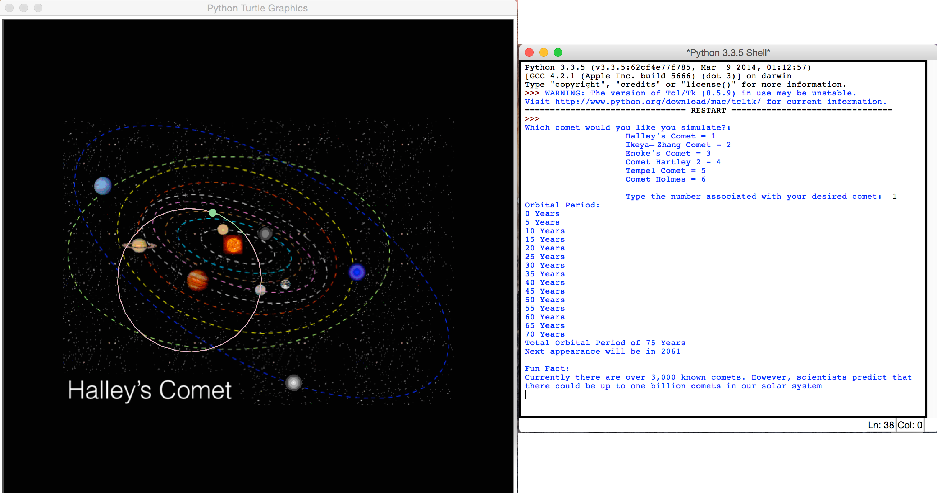omet fact.

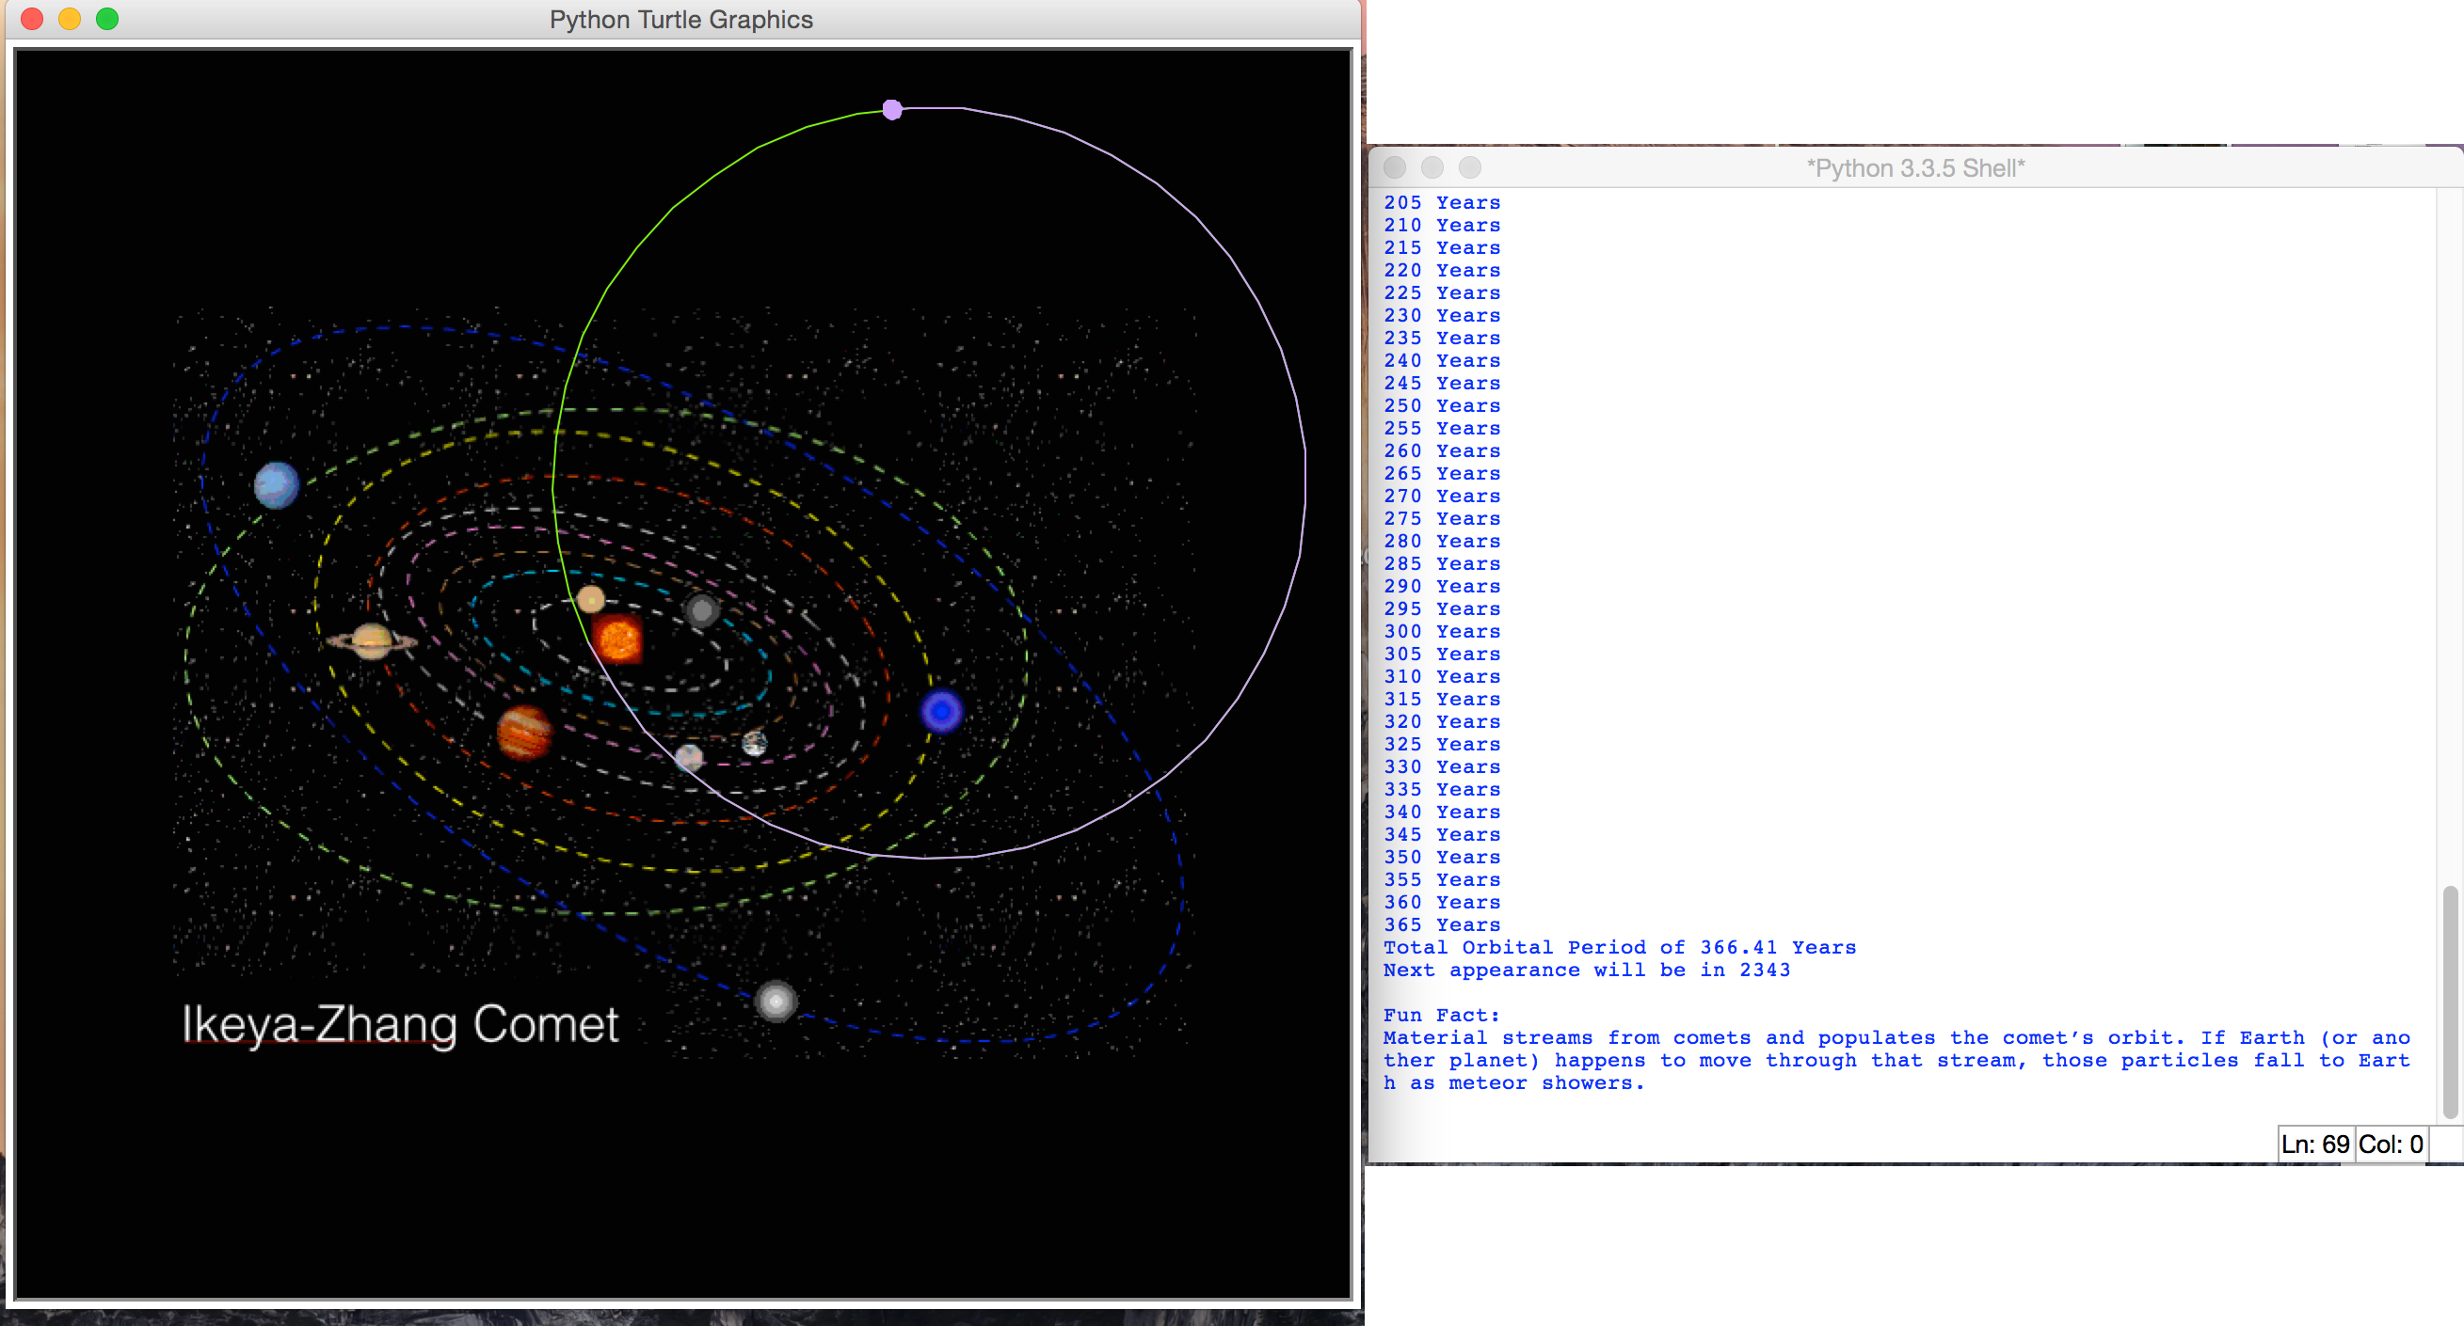

The other picture shown above shows another comet that was chosen. You can notice the different orbit and difference in orbital period. Also, the fact function has randomly chosen a different comet fact.